Pick-By-Light System Hardware Datasheet

The Pick-By-Light system (hereinafter called PBL) is powered by an ESP32 to which the LEDs are connected. One ESP32 corresponds to one sparepartscontainer, multiple ESP32s are connected via WIFI to a single Raspberry Pi which holds the Frontend and Backend software structures.

In the following datasheet only the hardware components of one sparepartscontainer will be discussed.

Used hardware:

Microcontroller: ESP32
LEDs: Adafruit Flora Smart NeoPixel RGB LED v2 (WS2812B controller)

Wiring Diagram:
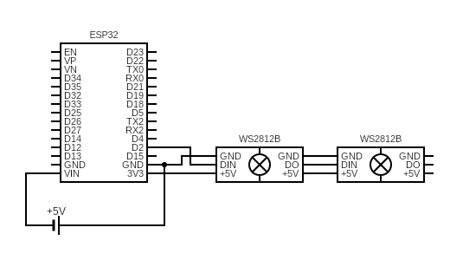
Power Consumption:

One NeoPixel draws a maximum of 60mA if all color values are at 100%.
One sparepartscontainer with 48 compartments and so 48 LEDs draws a total of 2,9A at 3,3V.

Depending on how many compartments and LEDs you have per sparepartscontainer you can either power the whole system via the ESP32's pins (as shown in the above wiring diagram) or via a seperate powersupply. If you use the latter option make sure the ESP32 and the LEDs are connected to the same GROUND.

To find a suitable powersupply you can calculate the maximum powerconsumption of your sparepartscontainer with following formusla:

60mA x (NumberOfLEDs) = Powerdrawage

The PBL system can only be powered by a maximum of 5V DC.

For further explanation of powerconsumption consult the adafruit website:
https://learn.adafruit.com/adafruit-neopixel-uberguide/powering-neopixels

